Site Analysis

Investigative Questions: What are proper techniques to conducts a site analysis? How has land use changed our landscape?

Goal: Students will analyze two separate sites at Blandy Experimental farm using proper observation and analysis techniques.

Learning Objective: Understand how land use may be altered if manmade structures were built at Blandy.

Knowledge:

Key Concepts & Skills: Learn how to conduct a site analysis. Use observation skills.

Value: Students will understand the impacts of land use

Virginia Science SOL: Science (2018) 6.1, 6.9

Materials
- Clipboards
- Pencils

Special Safety
- Advise students and their chaperones to follow the rules of the Arboretum
  - Refrain from climbing on the trees and rock walls.
  - Please do not pick or break living and non-living things.
- Remember: Other groups will be out learning and conducting experiments. PLEASE avoid other groups.
Background
- Background: Students should have conducted a site analysis prior to arriving at their school. However, please go over effective modeling techniques to practice their observation skills today.

- Students should already be grouped into 4 groups of equal numbers prior to the trip. Student groups will remain the same for the entire length of the project.
Procedure
- Have students observe the Home site (bus parking area which is north of the Quarters building).
  - Inquire- What do we see? Look at the slope of the land, the landscape, and any buildings you might see.
  - Have students record their answers on their data sheet.
- Once students have made good observations of the home site, select one of the numbered sites featured on the map for one group to observe and analyze. Each group should have a different observation site.
  - Further observation questions for each site can be found at the end of the datasheets.
- NOTICE: Every student group needs a chaperone. If there are not enough chaperones, then students do not go out on Blandy grounds alone. Student groups will combine and do the same site.
- Remind students that each group member has a role during their site analysis.
- Recorder- responsible for taking notes in the field
- Supporters- (Everyone is a supporter!) You help the team by brainstorming answers to the questions.
- Reporter- You will be responsible for entering in your data on the Google Form once you return to the classroom.
- The second site analysis (Home site & one other site) will take approximately 20 minutes. If possible, have students meet back at the Blandy Classroom with 10 minutes left in the rotation.
- Students will scan the QR code with their chrome books. The QR code can be found on the direction sheet. This QR code will send them to an electronic form that they will transfer their site analysis information onto.
  - While students are entering their information, have the reporter from each group provide a summary of the location they analyzed.
  - Do they believe their location will be a good place for the Education building?

Site Analysis Directions

Welcome to the bus parking area. This area is used as overflow parking during big events and for school bus parking during student field investigations. Here is where you will practice your site analysis skills. Take a minute and look around. What do you see? Look at the slope of the land, the landscape, and any buildings you might see. In your group, use your awesome observational and critical thinking skills to see if you can answer the questions below.

- How has the location been used historically?

- How is the location being used currently?

- Look around. Predict how this location might be changed if a building is built here.

- Can you find evidence of plant or animal life? Is this natural or manmade?

Now that you have had a chance to practice, it is time for you to investigate a site of your own. Since we are short on time, each group will be assigned a location to investigate.

- You have 20 minutes to complete your analysis. Each person in your group should take a role:
- Recorder- responsible for taking notes in the field
- Supporters- (Everyone is a supporter!) you help the team by brainstorming answers to the questions.
- Reporter- You will be responsible for entering in your data on the Google Form once you return to the classroom.

- Once you are done, meet back at the Blandy Community Classroom. Scan the QR code with your tablet to access the electronic site analysis form. Enter your site analysis information on the form.

- When you get back to school to finish your project, you will have access to everyone’s notes as you answer the question- Should Blandy Experimental Farm build a new educational building?

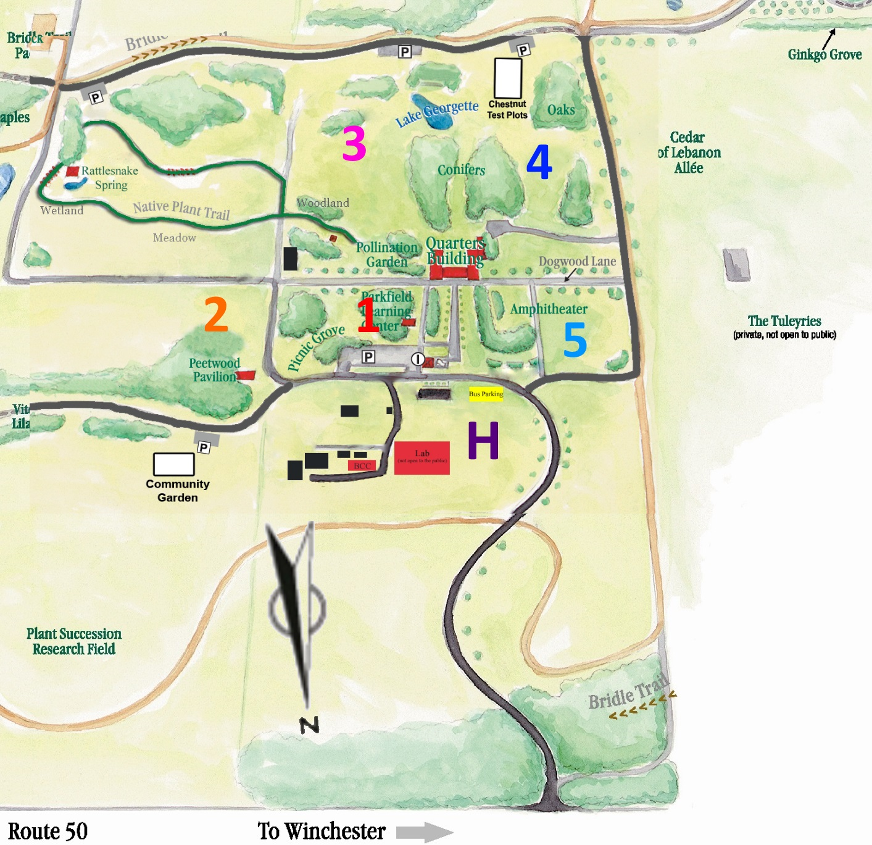
Use the map above to guide you to your assigned station.
Site H: (Home) Bus parking area - currently used for overflow/event/bus parking - how could that be adjusted?

Site 1: 1940’s Research Green House- This site is the current location of the research greenhouse built in the 1940s. As you can see, it is run down and far away from the new laboratory near the bus area. The plan is to tear down this structure and build a new greenhouse closer to the lab. Could they use this site as the home for the new educational building?

Site 2: Peetwood Pavilion Field- This site is south of Peetwood Pavilion and in Blandy’s native plant meadows. Do you think the meadows play an important part in the ecosystem? If you chose to build here, what would happen to the meadows? Do you see any other area around here that you might be able to build and preserve the meadows? Is this site close enough to the parking areas?

Site 3: Field next to Lake Georgette- This site is in the middle of the meadow to the east of Lake Georgette and south of the native plant trail woodland. This area has flooded in the past during times of heavy rain. Look towards Rattlesnake Springs, how does the land slope? Can you point to where you think the water would flow? How would building here impact water flow?

Site 4: Field near Chestnut Grove- this site is to the west of Lake Georgette and north of the chestnut tree grove. While it looks open and flat, it floods whenever there is a lot of rain. Is it close enough to infrastructure and road access?

Site 5: Event Field- It is a nice flat area and is used for Arborfest and Garden Fair. If you chose to build here what would happen to those events? Could they still be held?

Land Use Analysis: Blandy Experimental Farm
Directions: Complete the charts below.

Team Members
Site Number

Questions | Answer
How has the location been used historically?
How is the location being used currently?
When it rains, where does the water flow?
Look around. Predict how this location might be changed if a building was built here.

