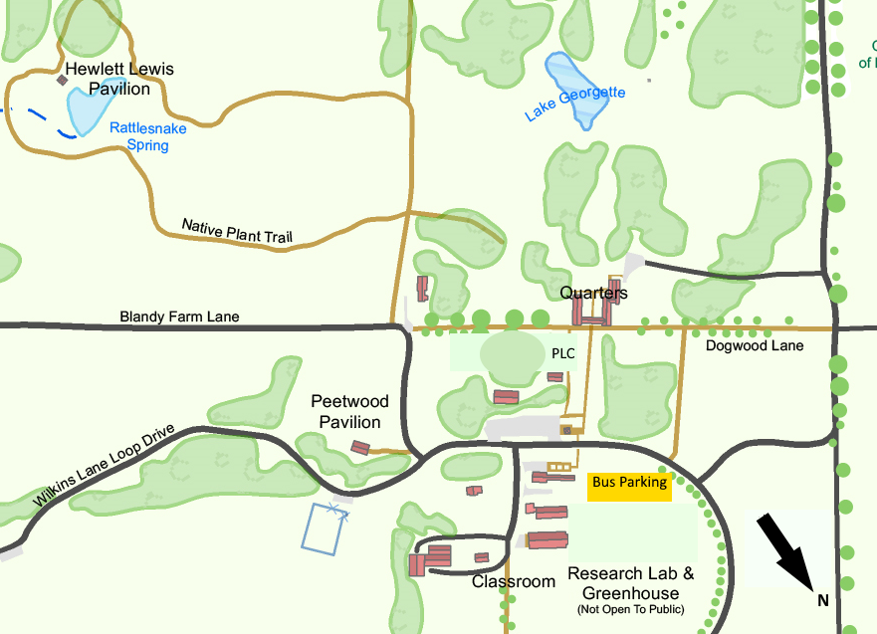

**Circle of Life**

**NPT Forest Layers**

**Tree Perspectives**

**Native & Invasives**

**LUNCH**

** EAST Route 50 WEST **

Restrooms are located at Peetwood Pavilion and in the Quarters. Main office 540-837-1758 ext. 0

|  |  |  |  |  |
| --- | --- | --- | --- | --- |
| Activity-  *Location-*  **Led by** | Circle of Life *Meet at Quarters Arch* -  **Blandy Educator Led** | Natives & Invasives –*Peetwood-*  **Blandy Educator Led** | Native Plant Trail Investigations – *Native Plant Woodland*– **Blandy Educator Led** | TREE perspectives- *Library-*  **Teacher led** |
| 10-10:30 | A | B | C | D |
| 10:30-11 | D | A | B | C |
| 11:00-11:30 | C | D | A | B |
| 11:30-12 | B | C | D | A |
| 12 -12:30 | LUNCH for ALL in Picnic Grove-  Teacher led | | | |