SAMPLE SCHEDULE FOR YOUNG ECOLOGISTS AT BLANDY EXPERIMENTAL FARM
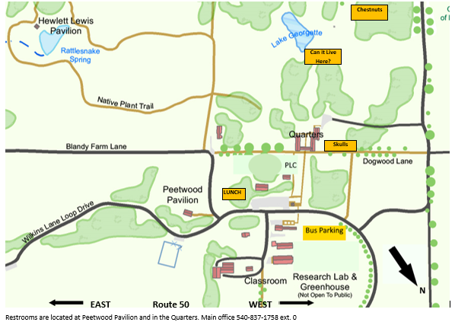

Subject- Location- Leader | Can it Live Here? - Lake Georgette- BEF educator | Chestnuts – Chestnut Grove - BEF educator | Skull ID- PLC  BEF educator
10-10:50 | A | B | C
10:55-11:45 | C | A | B
11:50-12:15 | Lunch in place
12:20-1:10 | B | C | A

*YOUR SCHEDULE WILL VARY DEPENDING ON NUMBER OF CLASSES AND OTHER FACTORS TO BE DISCUSSED WITH EDUCATORS.

